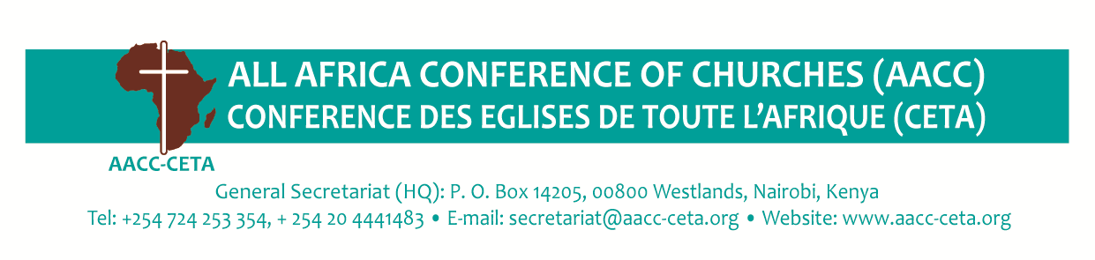
ON THE WAY TO THE ALL AFRICA YOUTH CONGRESS
ACCRA 2022

The All Africa Youth Congress (AAYC) is an initiative of the All Africa Conference of Churches' (AACC) to facilitate the continental Youth Campaign on African patriotism. The All Africa Youth Congress christened “Accra 2022” happens to be the first organized by AACC. The Congress will no doubt be a viable space for approximately 2,000 young people, male and female from 52 Countries in Africa between the age bracket of 15-35 years, in the Diaspora, and from among people of African descent and runs from 31st October to 5th November 2022 in Accra Ghana.
The following are the thematic areas:
YOUTH AND AFRICAN PATRIOTISM
- Celebrating arts, culture and heritage
- Showcasing youth innovation, entrepreneurship and job creation
- Embracing youth in cyber technology and development
ACTIVE CITIZENSHIP
- Youth participation in governance and decision-making in Political processes
- Ending corruption in Africa, addressing transparency and accountability in Africa
- Building a new generation of Patriotic African leaders
JUSTICE AND SECURITY
- Confronting climate change
- Youth for gender justice ϖ Silencing the guns
- Addressing inequality and injustice in the extractive industry ϖ
- Mitigation of human trafficking and irregular immigration
- Responding to Africa’s emerging debt crisis
AFRICAN DIGNITY
- Responding to disease crisis
- Addressing inequality and discrimination against people with disabilities
- Overcoming xenophobia, racism, religious persecution, Afrophobia ϖ Overcoming harmful traditional practices
- Wellness (mental, physical, spiritual, financial)
The AAYC invites partners, youth and developmental organizations to consider to express interest in organizing concurrent sessions / side events / seminars / workshops/ and exhibitions during the congress. All prospective partners should align their events/sessions and exhibitions to the themes of the congress.

Partners are expected to express interest in participating by highlighting their areas of focus, outlining the session/side event to be organized, names of organizers, proposed names of speakers, and how the event will contribute to the main theme. Africa: My Home. My Future or the sub-themes of the congress.
Submissions of interest should be sent to: youthcongress@aacc-ceta.org, email subject: Expression of Interest
